GidgieByte

Top drivers by miles

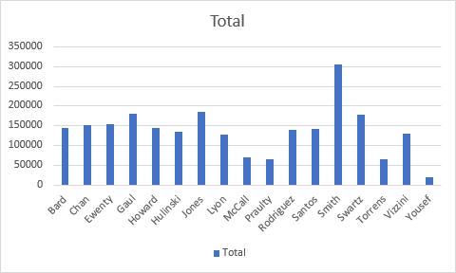

Scatter chart for the car inventory – Miles on each car

